
Company
Logotype

Cone Beam Computed Tomography- Report



Porur Dental X-rays & CBCT

Patient Name : Mrs. Hirunnisa | Date of Report : 14.05.2024
Age/ Gender : 76 years/ Female | Region of Interest : CBCT Full Skull
Referring doctor: Dr. Vigneshwar | Indication : Implant assessment
Clinical Notes: Nil
PATIENT INFORMATION

CBCT- Full Skull provided
CBCT – IMAGE DETAILS

RADIOGRAPHIC INTERPRETATION

- Complete loss of crown and root structure in relation to 16, 18, 21, 28, 36, 37, 38, 44, 45, 46, 47, 48.
- The alveolar ridge in relation to the maxillary and mandibular alveolar ridge is present with normal trabecular pattern.
- Presence of hyperdense crown structures in relation to 23, 24, 25, 26, 27, 31, 32, 41, 42.
- Presence of bone loss extending upto the middle third of all the teeth is evident.

IMPLANT ASSESSMENT

 | 11 region | 12 region | 13 region | 14 region | 21 region | 22 region | 23 region | 24 region
Sub-Crestal | 7.1 | 7.8 | 8.4 | 8.7 | 5.9 | 6.8 | 7.8 | 8.6
Mid- Crestal | 7.7 | 6.9 | 7.9 | 8.5 | 6.9 | 6.7 | 7.6 | 8.8
Distance between the alveolar ridge and Floor of the Nasal cavity (in mm) | 18.7 | 19.3 | 21.7 | 17 | 20.5 | 19.6 | 21.5 | 13.1

 | 15 region | 16 region | 17 region | 25 region | 26 region | 27 region
Sub-Crestal (in mm) | 10.5 | 10.3 | 13 | 10 | 10.3 | 11.7
Mid- Crestal (in mm) | 10 | 11.5 | 13.6 | 9.9 | 11.7 | 13.9
Distance between the alveolar ridge and floor of the maxillary sinus (in mm) | 13.3 | 16.1 | 10.7 | 18.8 | 15.8 | 13.4

 | 31 region | 32 region | 33 region | 34 region
Sub-Crestal (in mm) | 2.7 | 4.9 | 7.2 | 7.5
Mid- Crestal (in mm) | 4.3 | 5.3 | 9.2 | 7.1
Distance between alveolar ridge and the inferior border of mandible (in mm) | 26 | 25.3 | 20.1 | 24.1

 | 41 region | 42 region | 43 region | 44 region
Sub-Crestal (in mm) | 2.9 | 5.4 | 5.7 | 5.6
Mid- Crestal (in mm) | 3.5 | 5.8 | 5.7 | 6
Distance between alveolar ridge and the inferior border of mandible (in mm) | 26.5 | 27.4 | 25.4 | 25.3
 | 45 region | 46 region | 47 region
Sub-Crestal (in mm) | 5.6 | 6.4 | 8.2
Mid- Crestal (in mm) | 6.8 | 8.8 | 11.2
Distance between alveolar ridge and the inferior alveolar nerve canal (in mm) | 17.9 | 18.7 | 18.2
Distance between alveolar ridge and the inferior border of mandible (in mm) | 28.1 | 27.7 | 29

 | 35 region | 36 region | 37 region
Sub-Crestal (in mm) | 8 | 7.9 | 6.1
Mid- Crestal (in mm) | 8.1 | 8.5 | 7.1
Distance between alveolar ridge and the inferior alveolar nerve canal (in mm) | 16.7 | 22.1 | 19.7
Distance between alveolar ridge and the inferior border of mandible (in mm) | 30.7 | 31.3 | 29

RADIOGRAPHIC IMPRESSION

- Partially edentulous maxillary and mandibular arch.
- Generalized Chronic Periodontitis.

Kindly correlate with clinical findings


IMAGES FOR REFERENCE

RECONSTRUCTED PANORAMIC VIEW

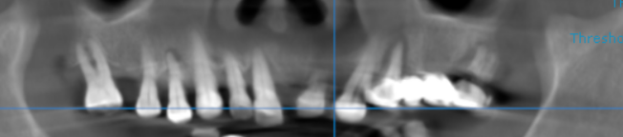

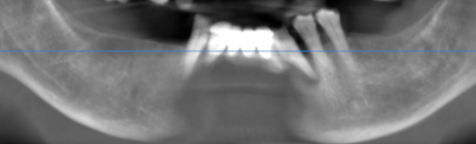

3-DIMENSIONAL VIEW
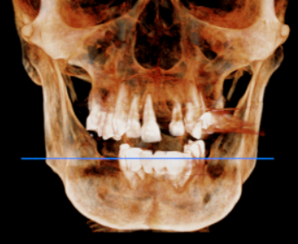

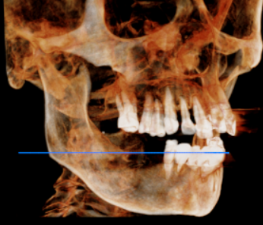
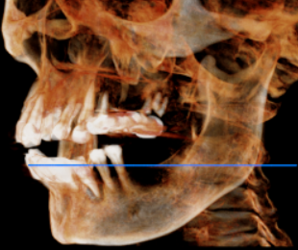

CROSS SECTIONAL VIEW

11 region | 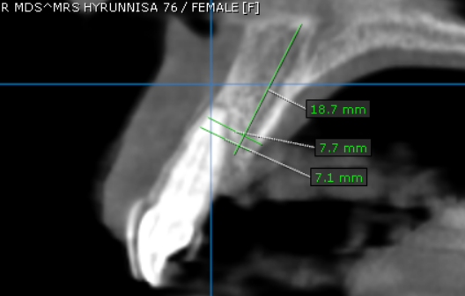
12 region | 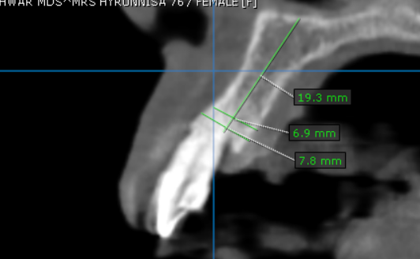
13 region | 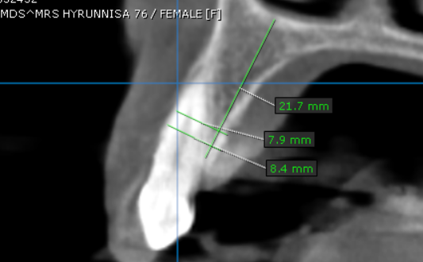
14 region | 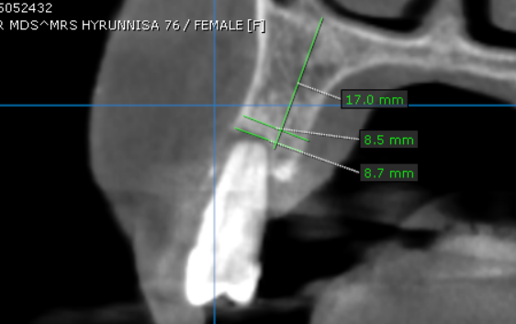
15 region | 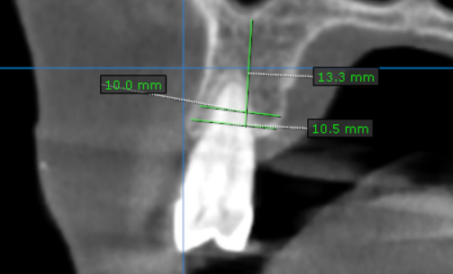
16 region | 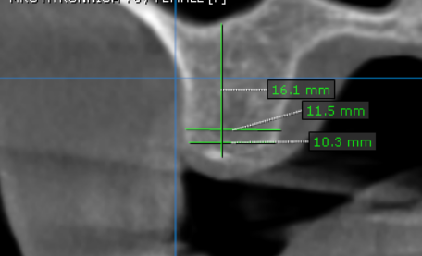
17 region | 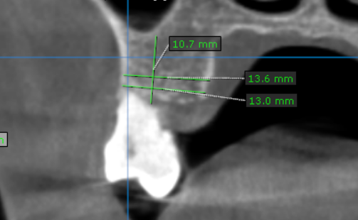
21 region | 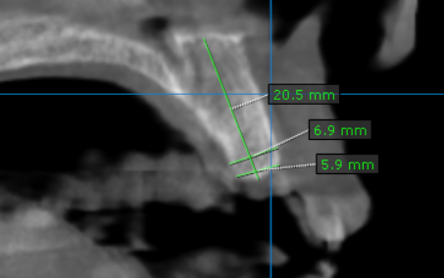
22 region | 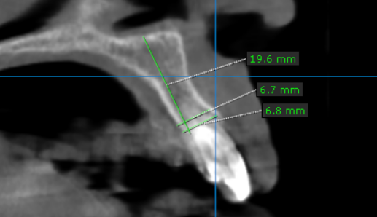
23 region | 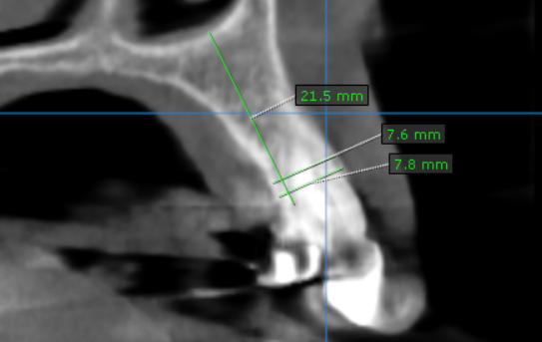
24 region | 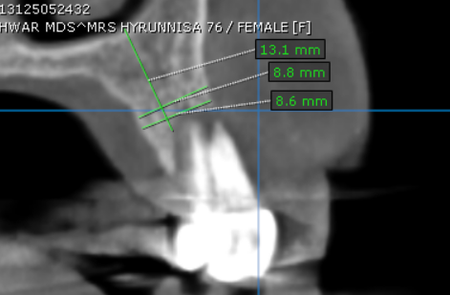
25 region | 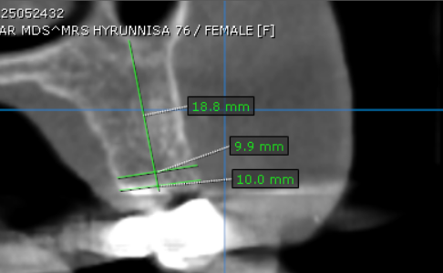
26 region | 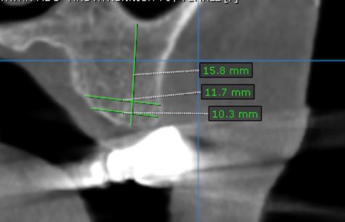
27 region | 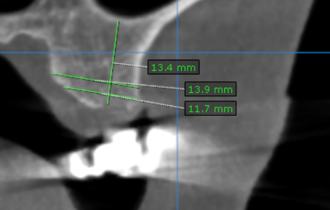
31 region | 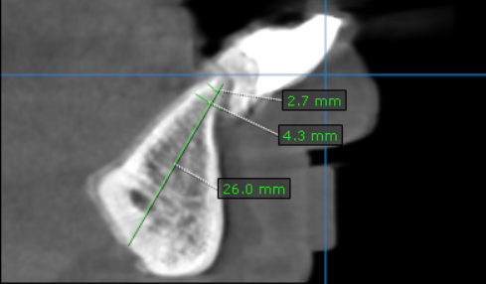
32 region | 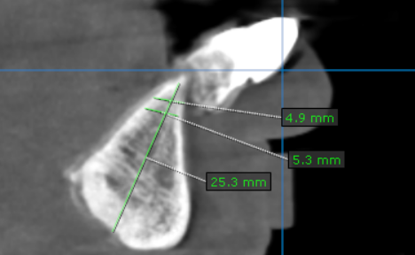
33 region | 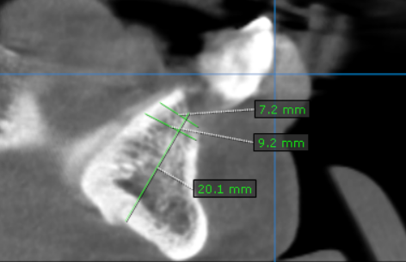
34 region | 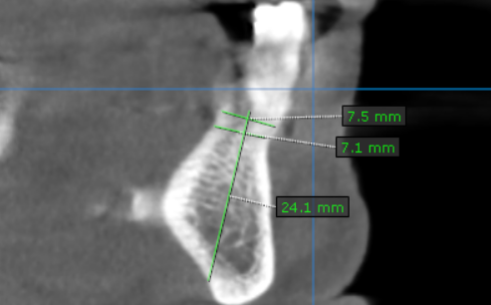
35 region | 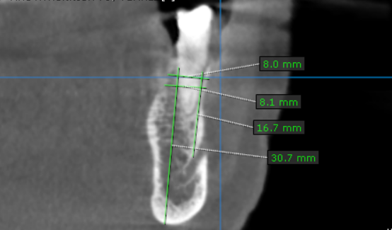
36 region | 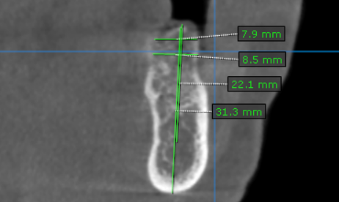
37 region | 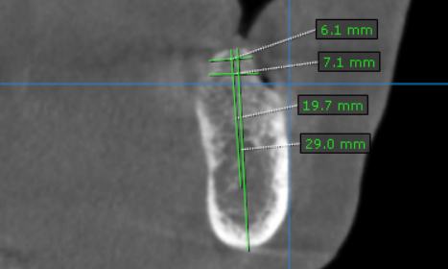
41 region | 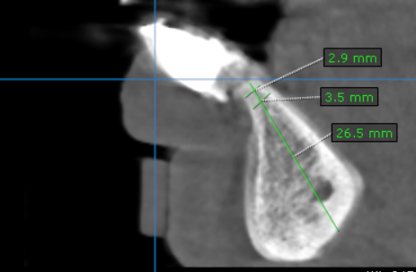
42 region | 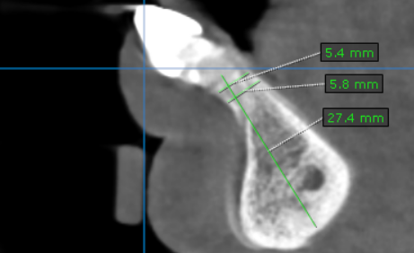
43 region | 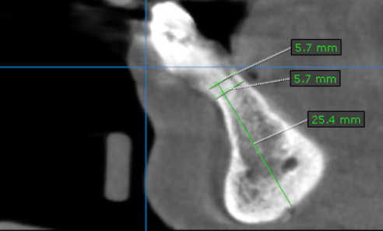
44 region | 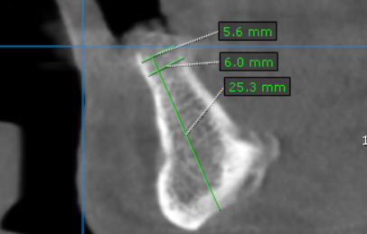
45 region | 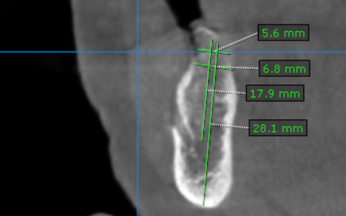
46 region | 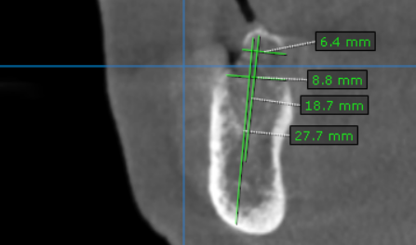
47 region | 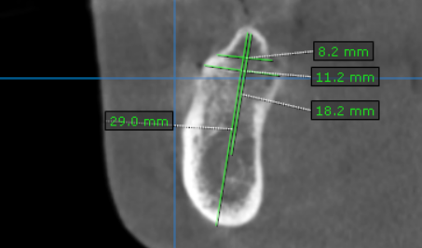

**** End of report ****

